Student Handbook Assistant

Industry Use Case Description: Student Handbook Assistant helps students quickly find accurate answers to questions related to academic policies, codes of conduct, attendance rules, grading systems, campus facilities, and student services. It retrieves information strictly from the official student handbook and related approved documents, ensuring responses are consistent, reliable, and aligned with institutional guidelines.
This assistant is well suited for schools, colleges, and universities, where students frequently seek clarity on policies and procedures. By reducing repetitive queries to administrative staff and improving access to verified information, the Student Handbook Assistant enhances student experience, supports compliance, and enables institutions to deliver scalable, always-available student support.

System Explanation:
Part 1: Document Upload → Chunk → Embed → Store
1. Google Drive Trigger – Automatically detects when a new student handbook document is uploaded to the monitored folder.
2. Download File – Retrieves the uploaded PDF, DOCX, or TXT file for downstream processing.
3. Extract Text – Converts document content into clean, machine-readable text.
4. Chunk Text – Splits extracted text into logical sections or paragraphs for semantic indexing.
5. Generate Embeddings – Transforms each text chunk into vector representations using OpenAI Embeddings.
6. Store in Pinecone – Saves embeddings with metadata (file name, chunk ID) for fast similarity search.

Part 2: Telegram Query → Search → Respond
1. Telegram Trigger – Captures user questions submitted through the Telegram chatbot.
2. Pinecone Query – Retrieves the top three most relevant student handbook document chunks based on semantic similarity.
3. OpenAI Chat – Generates a context-grounded answer using the retrieved student handbook document content.
4. Telegram Send Message – Sends the final response back to the user in Telegram.

Files Link:
https://www.manipal.edu/content/dam/manipal/mu/mtmc-jamshedpur/documents/documents/hand-book/Hand%20Book_2025.pdf
https://www.imperial.ac.uk/media/imperial-college/faculty-of-natural-sciences/department-of-mathematics/MLDS-Student-Hanbook-2025-2026.pdf
Google Drive Link for Sample Files:
https://drive.google.com/drive/folders/1JHgQ1fwQb8kosaDSPeum8t8nolML1Mk_?usp=drive_link
Github Link for Sample Files:
https://github.com/rajeshksharmasls/GenAI/tree/2ca9f165275df806ccd73f5bcff32a9e37828e93/GenAI/Automation/Student%20Handbook%20Assistant/Sample%20Files

Custom System Prompt:
You are a helpful Student Handbook Assistant Bot that assists users by answering questions based only on the uploaded Student Handbook and official academic policy documents, such as academic rules, attendance policies, examination regulations, grading systems, code of conduct, disciplinary procedures, and student guidelines.
Your role is to retrieve and summarize information strictly from the provided Student Handbook documentation.
You must generate responses only from the given context (uploaded Student Handbook documents and policy sections).
If a user asks a question that is not related to the uploaded Student Handbook documents, respond exactly with:
“I can only assist with questions related to the Student Handbook.”
If no relevant information or sections are found in the provided context, respond exactly with:
“I couldn’t find information related to your query in the Student Handbook.”
Do not provide any additional information.
Do not generate, infer, or interpret responses using your own knowledge.
Do not answer questions outside the scope of the uploaded Student Handbook documentation.

Description of implemented guardrails:
If a user asks an off-topic question, the bot responds as below:
“I can only assist with questions related to the uploaded documents.”
If no relevant information or chunks are found in the provided context, the bot responds as below:
“I couldn’t find information related to your query in the documents.”

Screenshots of bot responses for test queries:
Positive Responses
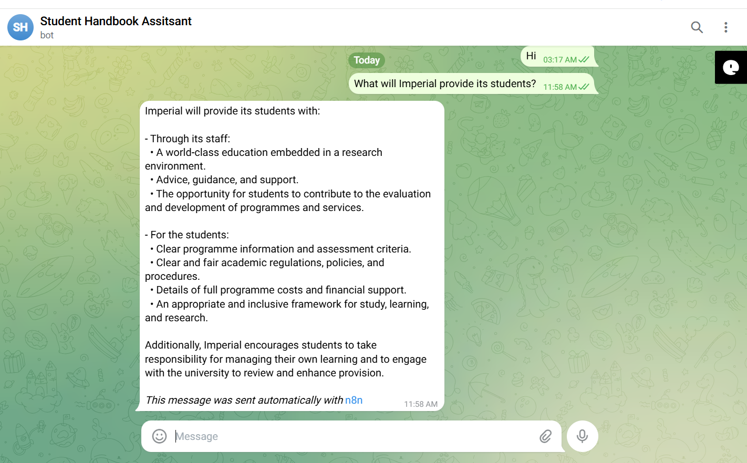
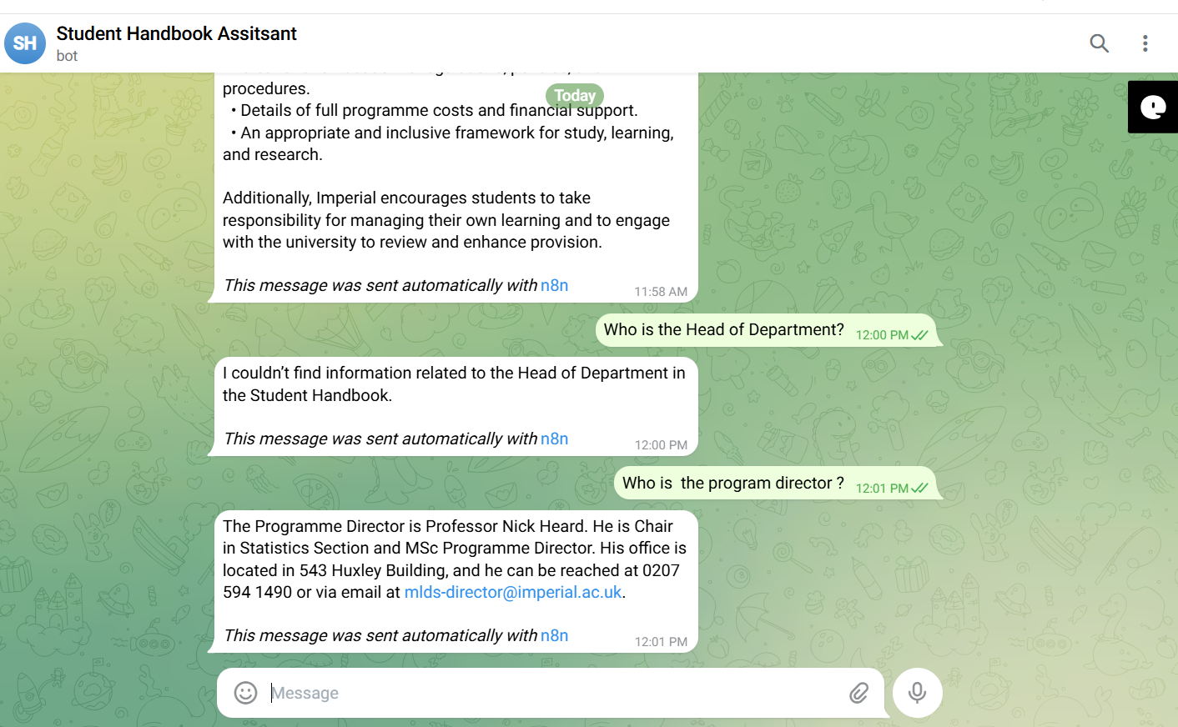
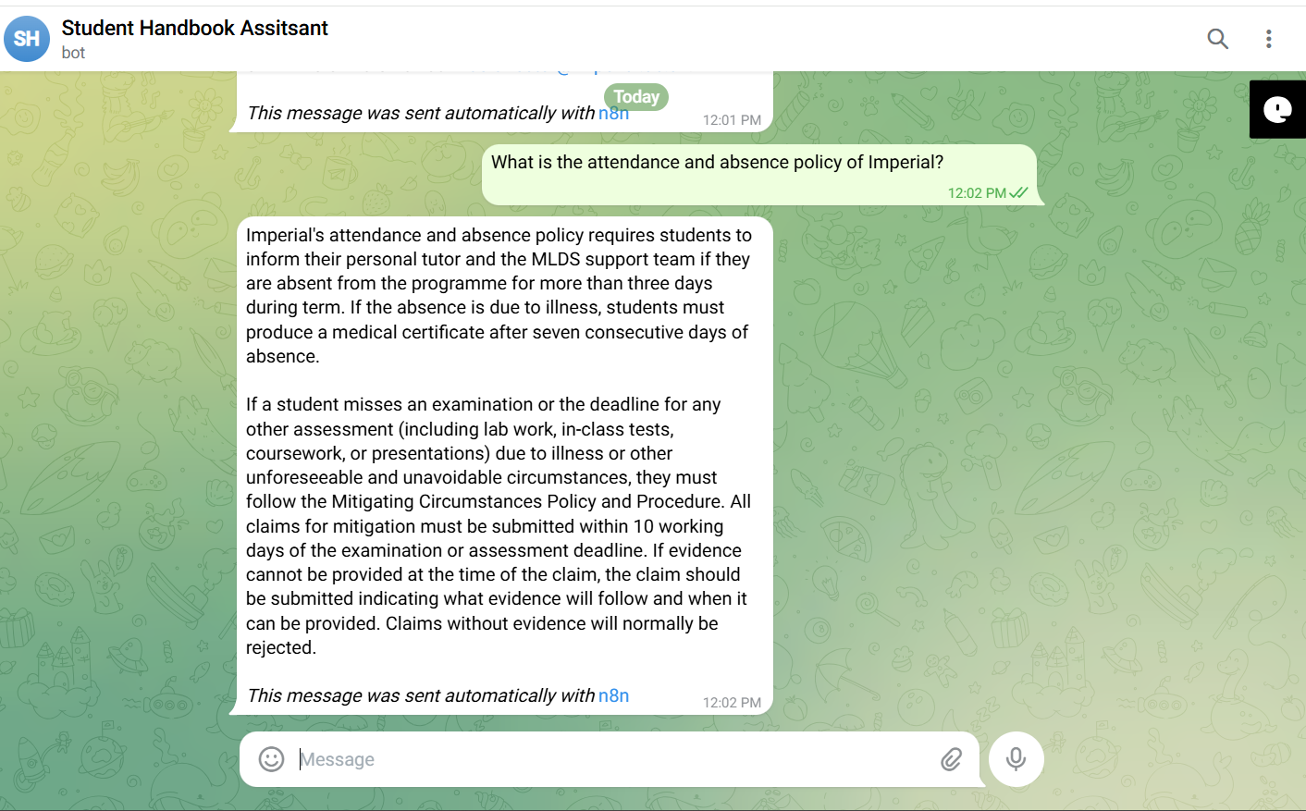
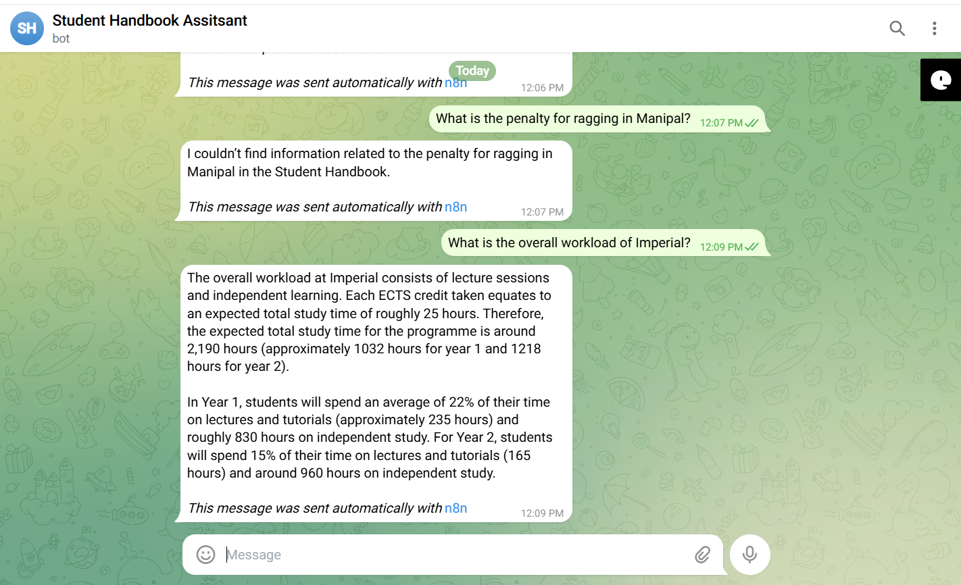

Negative/Off topic Responses
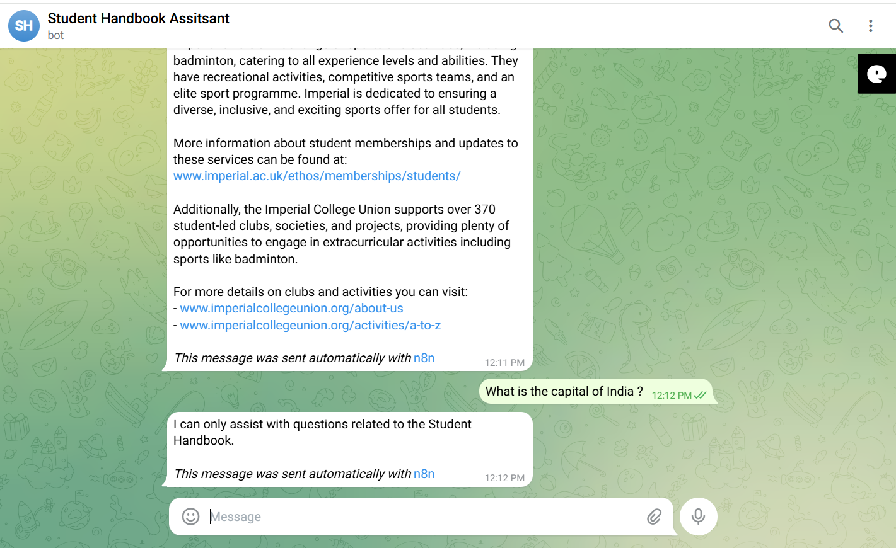
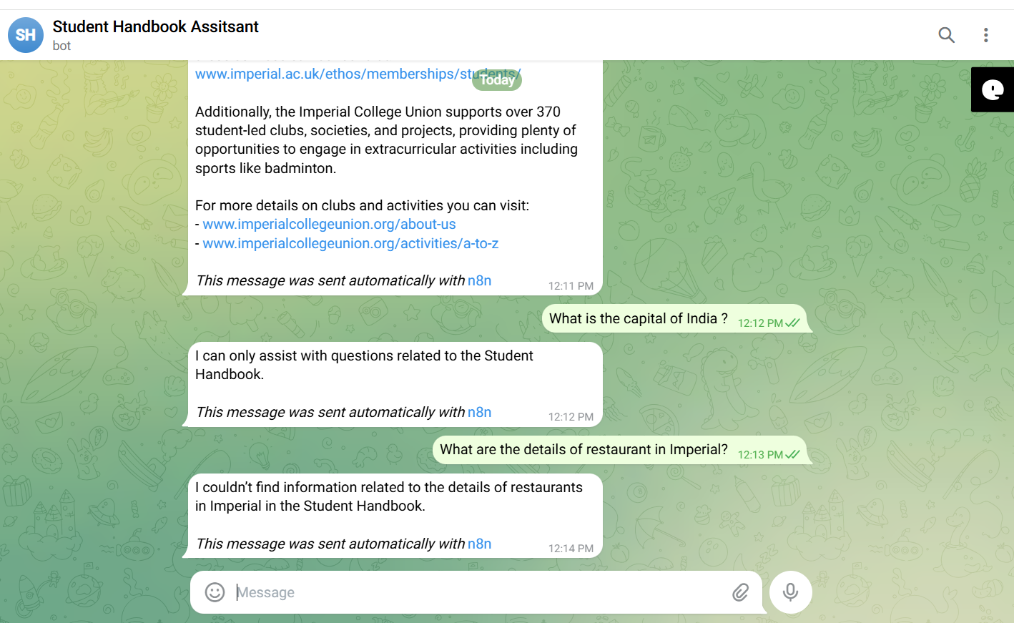

Screenshots of complete n8n flow architecture:
Document Upload:
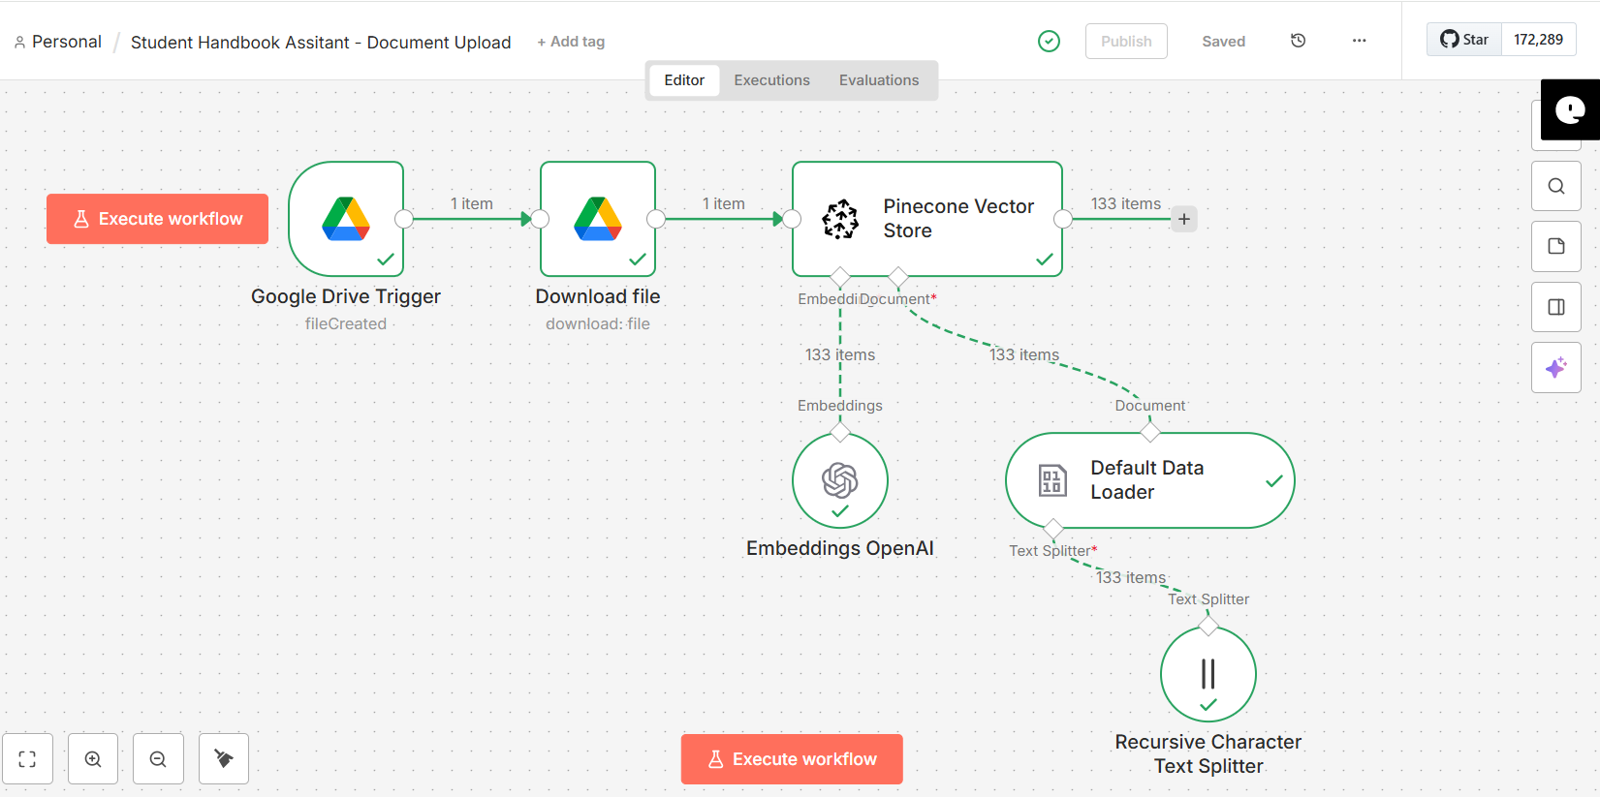

Telegram Bot Flow:
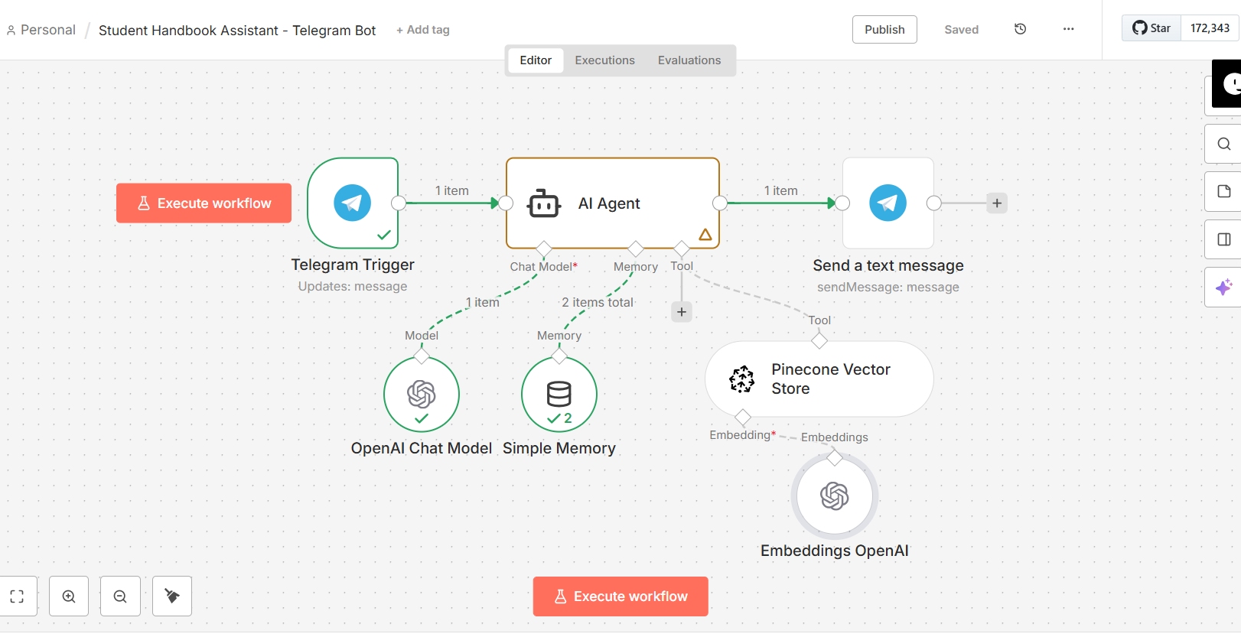

JSON files git hub link:
https://github.com/rajeshksharmasls/GenAI/tree/2ca9f165275df806ccd73f5bcff32a9e37828e93/GenAI/Automation/Student%20Handbook%20Assistant/JSON

Demo git hub link:
https://github.com/rajeshksharmasls/GenAI/tree/2ca9f165275df806ccd73f5bcff32a9e37828e93/GenAI/Automation/Student%20Handbook%20Assistant/Demo

Telegram bot username:
student_handbook_assistant_bot

Challenges faced:
Below are the challenges faced:
- Student handbooks are lengthy and policy-heavy, making precise retrieval difficult at times
- Academic rules and regulations change frequently which results in outdated responses
- Preventing interpretations or advice beyond official student handbook content
- New students often ask vague or situational questions resulting in incorrect responses
- Similar policies may spread across multiple handbook sections
- Different rules for undergraduate, postgraduate, or specific programs
- High risk of misinformation impacting academic decisions
- Clearly handling “information not found” scenarios without confusion

